Visit Report: Raipur Upazila Health Complex, Lakshmipur
Date of Visit: 12/09/22; Time: 9:00 AM.
Visitor: Dr. Md. Emdadul Haque, National Consultant (HEU) &
Dr. Nazmur Rahman Sajib, Junior National Consultant (HEU)

Objectives of the visit:
1. To perform the baseline health survey of the UHC
2. Discussion on the SSK program and importance of quality of health care.

Activities:
1. We arrived in Raipur UHC at 9:00 am. All consultants and medical officers were present at the conference room of the UHC. We discuss with them about the SSK and overall situation of the health complex.
2. There are 10 unions under the UHC having 3,13,760 populations. There are two Sub-centers, 8 H&FWC and 34 Community Clinics in this Upazilla.
3. The infra-structure of this Upazila Health Complex is 50 bedded. Cleanliness of the hospital premises is average. We observed emergency, outdoor, pathology and pharmacy department. There is no separate section for male, female and children in OPD.
4. Out of 10 posts of junior consultant, 7 posts including gynae and anesthesia are vacant. Medical officer (Dental) post is vacant.
5. There is no cycle stand. There are many motorcycles parked in the premises.
6. The information display system was weak. Most of the information is handwritten. They are being advised to use Pana/notice board to display information. There is no corner for health education for OPD patients and their attendants.
7.The X-ray, USG and ECG machine are well functioning. In OPD, some of the medical officers performing USG on regular basis.
8.The spaces of emergency is satisfactory. There are some spaces close to the emergency room where SSK Booth and Pharmacy can be established. There are separate O.T room and labor room. There is an extra functioning anesthesia machine in the OT room.
9. Cleanliness of the hospital premises, outdoor and indoor was not satisfactory. waste management system needs to be improved.
10. There are spaces for SSK booth and pharmacy close to the emergency dept.
11. In 2021, total OPD patient was 98,698, in emergency 4476 and in indoor admitted patient was 6697. Bed occupancy rate was 79%. Total ANC 1st visit in 2021 was 1415 and total delivery was 507.

Health Profile of Raipur UHC:
Total population: 3,13,760
Union: 10 Sub-centre: 2 FWC:8 Community Clinic: 34

Human Resources: 50 Bedded Hospital:
Sl. | Designation | No. of Post | Present | Vacant
1. | UH&FPO | 01 | 01 | 0
2 | RMO | 01 | 01 | 0
3. | Junior Consultant | 10 | 03 | 07
4. | Medical Officer (incl. sub-centre) | 08 | 07 | 01
5. | MO(Dental) | 01 | 0 | 01
6. | Medical Officer (OSD) | 0 | - | -
7. | Nurses | 31 | 22+1 in deputation outside | 09
8. | Mid wives | 04 | 03 | 01
9. | Medical Technologist (Lab) | 04+1 | 01+1 | 03
10. | MT EPI | 01 | 01 | 0
11. | MT(Dental) | 01 | 01 | 0
12 | MT (Radiology) | 01 | 0 | 01
13. | SACMO (UHC + Field) | 12 (2+10) | 09 | 03
14. | Pharmacist | 02 | 01 | 01
15. | Health Inspector (HI) | 04 | 0 | 04
16. | Sanitary Inspector | 01 | 01 | 0
17. | Assist. Health Inspector | 11 | 08 | 03
18. | Health Assistant | 55 | 29 | 26
19. | CHCP | 34 | 31 | 03
20. | Head Assistant | 01 | 0 | 01
21. | Cashier | 01 | 0 | 01
22. | Accountant | 01 | 0 | 01
23. | Statistician | 01 | 01 | 0
24. | Office Assistant /Comp. Operator | 03 | 0 | 03
25. | Store Keeper | 01 | 0 | 01
26. | Cardiographer | 01 | 01 | 0
28. | MLSS+ Ward boy | 06 | 01 | 01
29. | Cleaner | 05 | 03+ 1 in deputation outside | 02
30. | Guard | 02 | 02 | 0
31. | Gardener | 01 | 01 | 0
32. | Cook | 02 | 0 | 02
33. | Attendant (Lab, Emergency, OT) | 03 | 03 | 0
34. | Driver(Ambulance) | 01 | 01 | 0
35. | Outsourcing: Driver(1+6)=7 | 07 | 07 | 0
36 | FWV | 11 | 10 | 01
37 | FPI | 07 | 06 | 01
37. | FWA | 47 | 36 | 11

Status in HSS Score From Jan-July (Total Dist. Hospital-64, Total UHC-423)
Name | Jan | Feb | Mar | April | May | June | July | Aug
Lakshmipur District Hospital | 2 | 1 | 2 | 2 | 3 | 3 | 55 | 55
Raipur UHC | 87 | 121 | 127 | 306 | 228 | 92 | 358 | 374
Ramganj UHC | 31 | 4 | 13 | 75 | 83 | 120 | 364 | 372
Kamalnagar UHC | 154 | 119 | 59 | 176 | 168 | 289 | 385 | 380
Ramgati UHC | 196 | 117 | 96 | 265 | 219 | 212 | 356 | 369

Status of Building Blocks of C-J Model in the Raipur UHC:
Sl | Criteria of C-J Model | Satisfactory | Average | Not Satisfactory
01 | Cycle stand close to the main gate |  |  | √
02 | Health Education |  |  | √
03 | Cleanliness & beautification |  | √
04 | Separation of patients in out door & indoor |  |  | √
05 | Blood doner list with 24/7 B.T facility |  | √
06 | Birth- death recording |  |  | √
07 | Reception Desk |  |  | √
08 | Developed Emergency Dept. | √
09 | 5S –KAIZEN implementation. |  |  | √
10 | Community Participation. |  | √
11 | Hospital activities Display |  |  | √
12 | Corner based service. |  | √
13 | Cash counter for receiving Govt money. |  |  | √
14 | Devolped maternal health/labour word. |  | √
15 | Devolped paediatric health |  |  | √
16 | Position in HSS score in July, 22. (Best= <100; Good= 101-200; Weak= >200) |  |  | √
17 | Power point Presentation &Video on UHC |  |  | √
18 | Knowledge about 8th Five Year plan & SDG. |  |  | √
19 | Zero-Tollarance on corruption |  | √

Recommendations:
1. Separation of OPD for male, female and children should be done to maintain quality of OPD services.
2. Rearrangement of male, female, labour and paediatric ward is necessary for maintain quality of indoor services.
3. The post of gynae and anesthesia consultant should be filled up immediately for the development of improved maternal health services.
4. All the vacant posts of 4th class should be fulfilled immediately.
5. Cleanliness and beautification is average. All unwanted posters should be removed. Condemetion Board should work to destory all unwanted items.
6. Hospital display system is weak. Most information are handwritten which needs to be replaced by notice board and pana.
7. The local Pouroshova must take part in waste management as health complex paid 13,00,000 Tk/year to Pouroshova.
8. There should be availability of safe drinking water for OPD patients.
9.The performance of all services must be improved, because of underutilization of the health complex.

Photos of Raipur UHC taken from the visit are shown below:
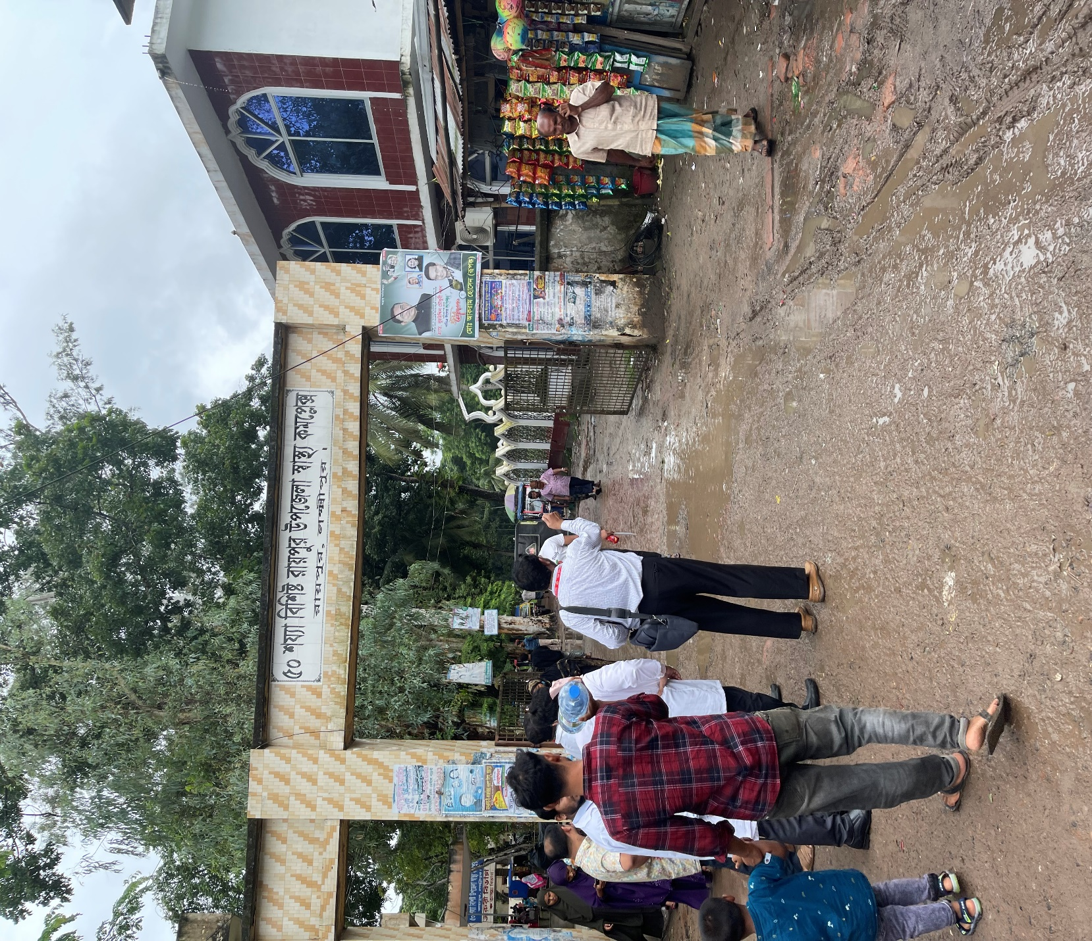
Fig-1: Front gate of Raipur UHC, but there is no guiding sign in the main road,
Gate is covered with lots of posters

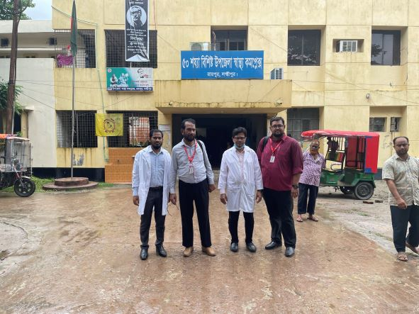

Fig-2: Entrance gate of Raipur UHC building

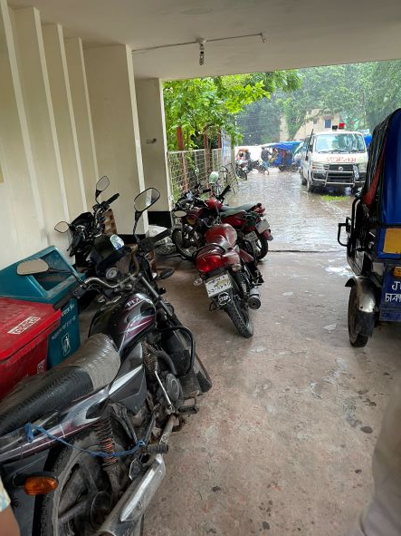

Fig-3: Motor cycle parked in front of hospital entrance, as there is no cycle stand close to the main gate

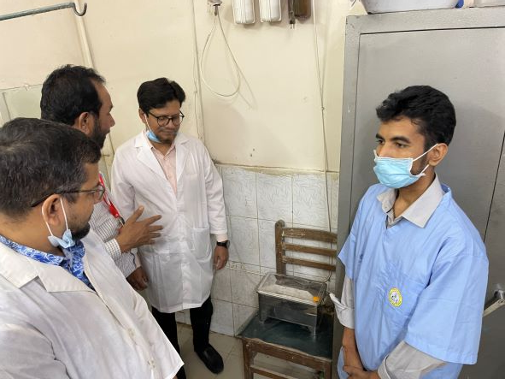

Fig-4: Sterilizer machine in the Emergency (Good Practice); but should not be placed on a chair
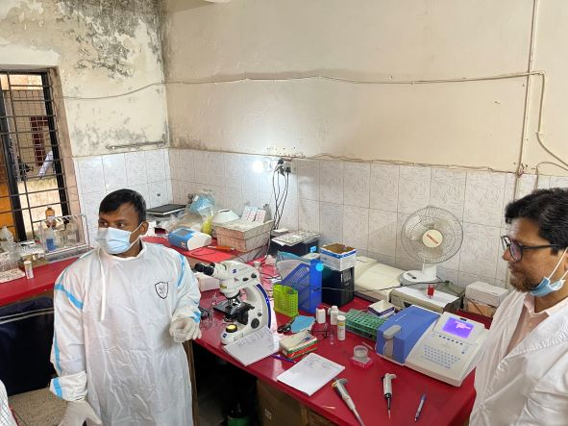

Fig-5: Pathology Lab; Medical Technologist (Lab) is using protective gown (Good Practice), but equipment are not well organized
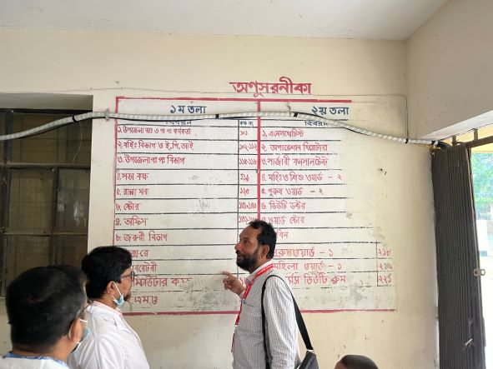
Fig-6: Direction should be updated and written in a Pana board
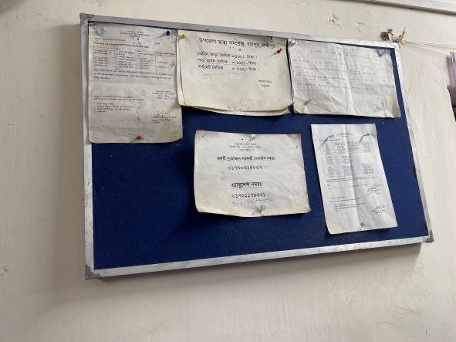
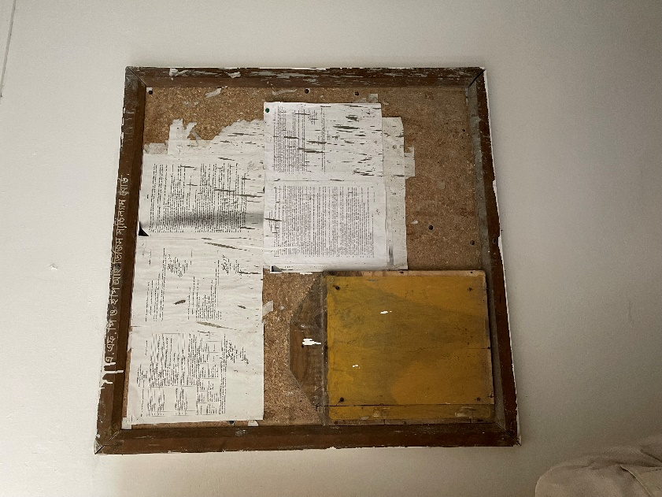

Fig-7,8: Display board should be digitalized with updated information

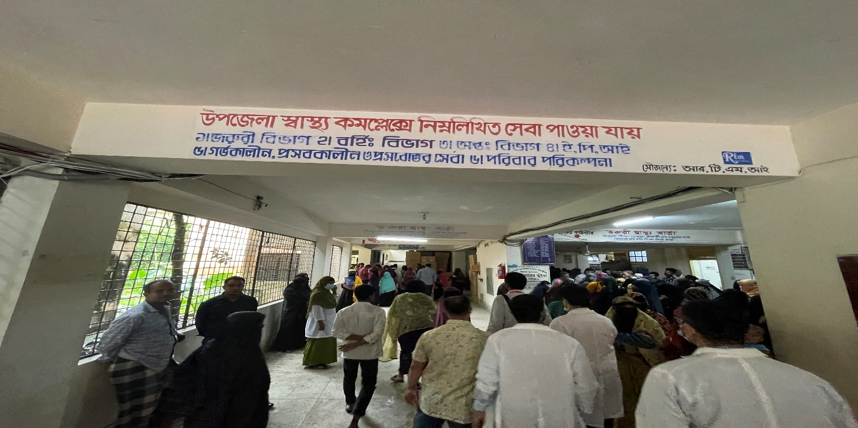

Fig-9: All types of wall writing should be avoided and should be digitalized using Pana board
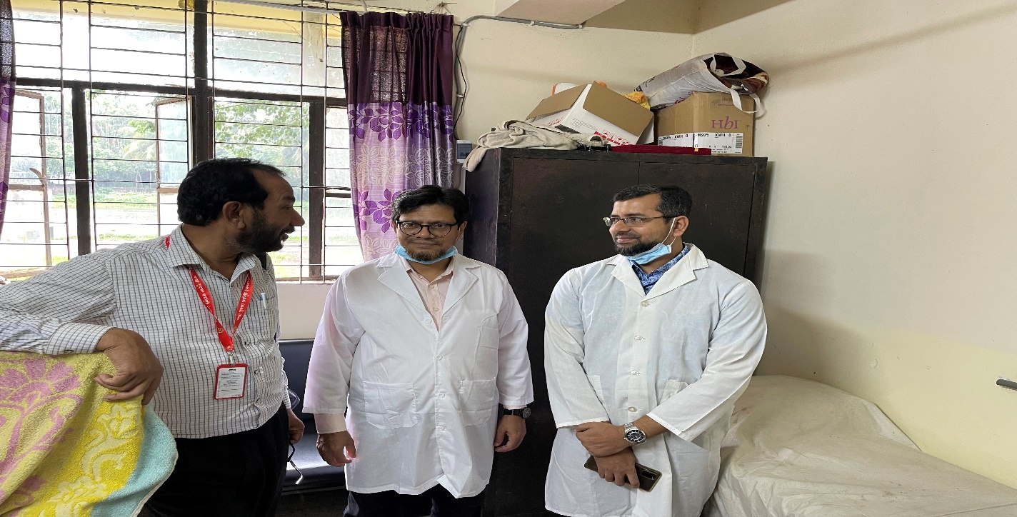

Fig-10: Any items should not be kept on the top of the Almirah

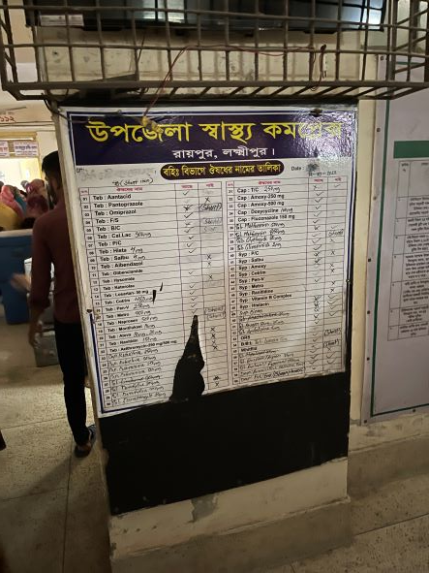

Fig-11: List of Supplied drugs for OPD; should be replaced with new one

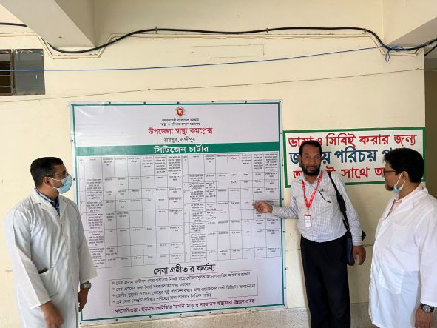

Fig-12: Citizen charter
(Good Practice)

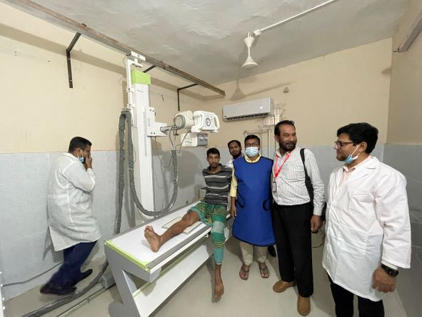

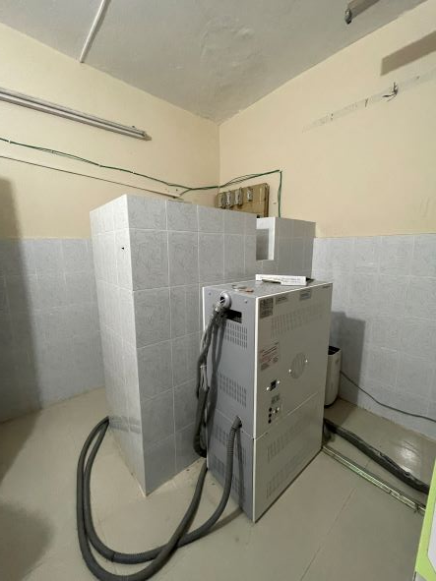

Fig-13,14: Functional X-ray room with medical technologist (Radiology) with developed protective system (Good Practice)
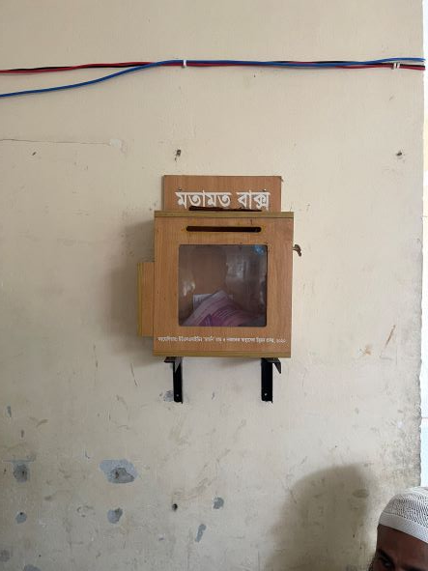

Fig-15: Suggestion Box (Good Practice), should be replaced by complain and suggestion box

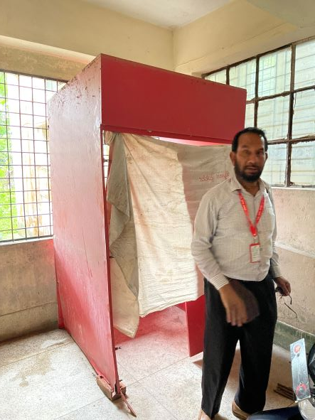
Fig-16: Unwanted item needs to be removed

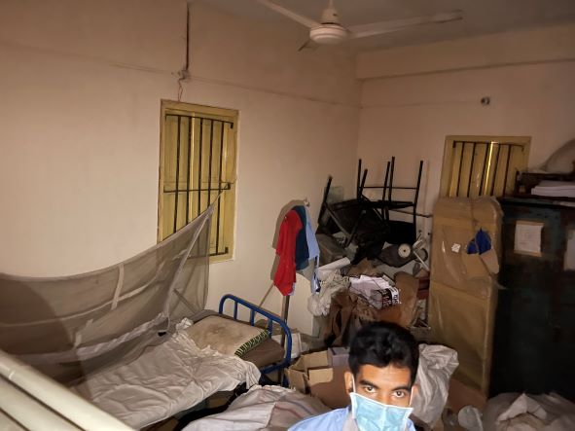
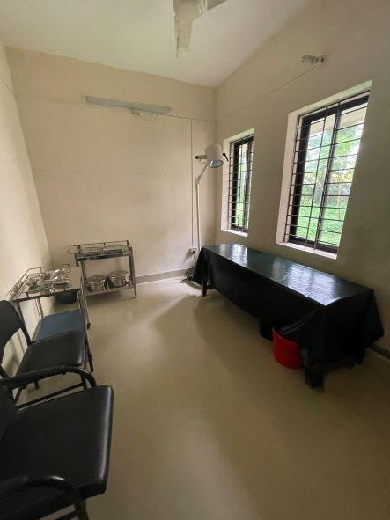

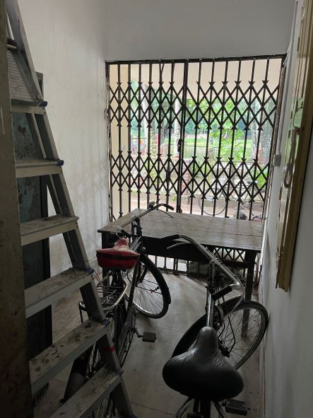

Fig-17,18,19: Proposed spaces for SSK Booth and Pharmacy; these areas should be cleaned

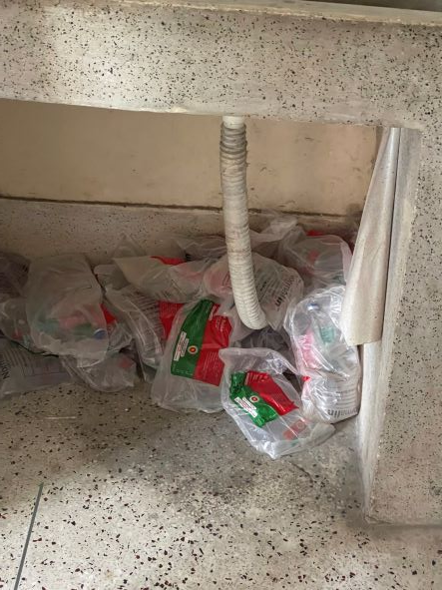
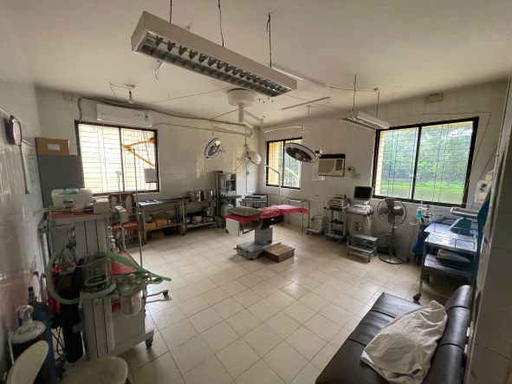
Fig-20: OT room; there are some unwanted items which occupy spaces, should be removed

super

Fig-21: Supplied saline and other medicines should be stored in appropriate places

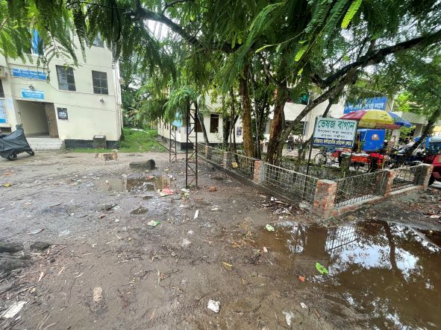

Fig-22: Proposed space for Cycle stand; area should be cleaned
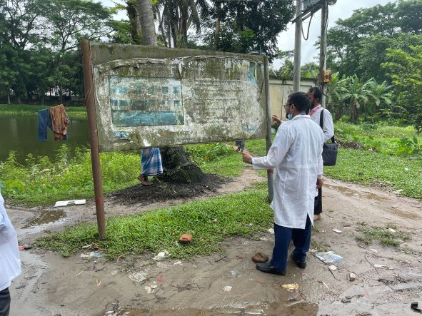
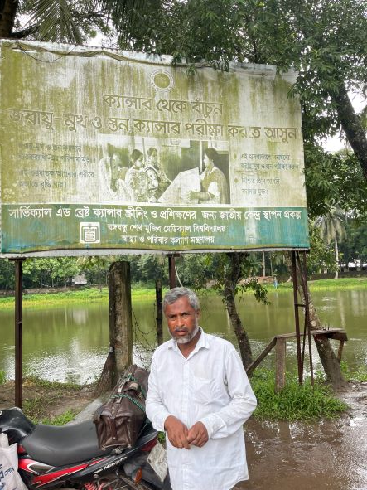

Fig-23: Unclean Bill board should be replaced by new health information
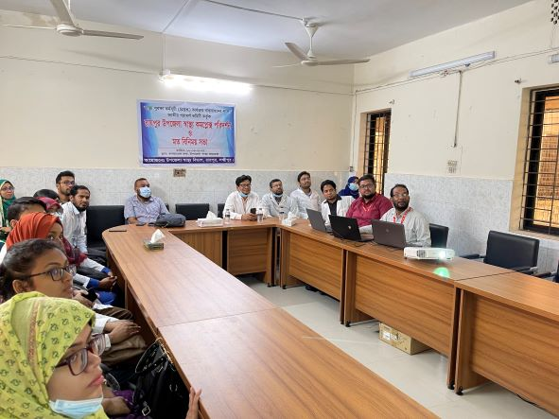
Fig-12: Discussion on SSK and quality of care with hospital staffs

